IBM SPSS Modeler Project

Project Title:
Healthcare Data Audit and Preparation Using IBM SPSS Modeler

Submitted by: Satyaprakash Jena
Sundaram Tiwary Course: B.Tech CSE (AI & DS)
Semester: 5th
Institution: Arka Jain University
Guide: Mr. Prajwal Deep Khokhar
Date: 29-11-2025

S. No. | Contents | Page No.
1. | Project Brief | 3
2. | Introduction | 4
3. | Feasibility Study | 5
4. | Project Details | 6
 | 4.1 Datasets Used | 6
 | 4.2 Data Understanding and preparation | 6-7
 | 4.3 Adding the Data Audit Node | 7-9
 | 4.4 Running the Data Audit and Observing Variable | 9-12
 | 4.5 Extracting Descriptive Statistics | 12
5. | Conclusion / Summary | 13
Index

1. Project Brief

This project focuses on performing a comprehensive Data Audit on a healthcare dataset using IBM SPSS Modeler. The main objective of the project is to evaluate the quality of the dataset before applying any predictive or analytical models. Healthcare datasets often contain missing fields, inconsistent values, and outliers due to human errors and system limitations. Therefore, ensuring data cleanliness and reliability is essential for accurate decision-making.
In this project, the Healthcare CSV dataset was imported into SPSS Modeler using the Var. File node. A Data Audit node was applied to examine important characteristics such as data types, measurement levels, missing values, ranges, distributions, and outliers. The Data Audit report allowed a quick visual and statistical review of each variable.
The audit identified several data quality issues, including missing values in categorical variables, outliers in numerical fields such as Age and Billing Amount, and uncommon or inconsistent category entries. These findings help determine what data cleaning steps such as imputation, outlier removal, or value standardization are required in the next stage.
Overall, this project demonstrates the importance of data understanding and data preparation in the CRISP-DM process. By identifying potential issues early, the dataset becomes more reliable for further modeling, prediction, or analysis in IBM SPSS Modeler.

2. Introduction
Healthcare datasets contain a wide range of information such as patient demographics, medical conditions, billing details, and treatment history. Before using this data for analysis or building predictive models, it is essential to check its accuracy and reliability. IBM SPSS Modeler provides an efficient environment for exploring and preparing such datasets through its visual node-based interface. One of the most useful tools is the Data Audit node, which generates detailed summaries including missing values, outliers, distributions, and basic statistics. In this project, the healthcare dataset was imported and examined using the Data Audit node to identify issues like incomplete records, inconsistent categories, and extreme values. This ensures the dataset is clean and ready for further analysis and modeling.

3. Feasibility Study
1. Technical Feasibility:
IBM SPSS Modeler provides built-in nodes such as Var. File, Type, and Data Audit, making it easy to import, explore, and assess the healthcare dataset without any coding.
2. Operational Feasibility:
The dataset is simple to load, and the drag-and-drop workflow allows smooth execution of the data audit process. Even beginners can perform all steps efficiently.
3. Economic Feasibility:
The project uses the educational version of SPSS Modeler and a freely available healthcare dataset, requiring no additional financial resources, making it cost-effective.

4. Project Details
4.1 Datasets Used
Healthcare Dataset (CSV Format)
This project uses a healthcare dataset containing patient-related information such as demographics, medical conditions, hospital admission details, billing amounts, blood type, insurance provider, and length of stay. The dataset includes both numerical and categorical variables, making it suitable for data auditing and preprocessing tasks in IBM SPSS Modeler.
Key Features of the Dataset:
- Patient Age
- Gender
- Blood Type
- Medical Condition
- Admission Type
- Insurance Provider
- Billing Amount
- Date of Admission and Discharge
- Derived field: Length of Stay

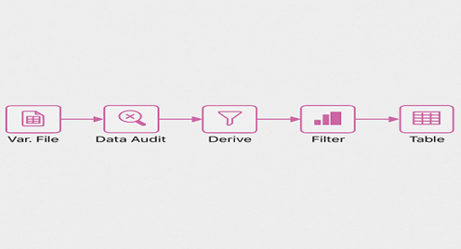

4.2 Data Understanding and Preparation
The healthcare dataset was imported into IBM SPSS Modeler using the Var. File node. After loading the CSV file, the Type node was used to automatically assign measurement levels such as nominal, ordinal, and continuous to each field. This step ensured that SPSS Modeler correctly identified variable types such as Age, Billing Amount, Gender, Medical Condition, and Admission Type.
Next, the Data Audit node was connected to examine the structure and quality of the dataset. The audit revealed the presence of missing values in fields like Blood Type, Insurance Provider, and Medical Condition. Outliers were observed in Age and Billing Amount, while some categorical fields contained inconsistent entries.
Based on these findings, the dataset was prepared for further analysis by identifying fields that require cleaning, imputation, and standardization before modeling.

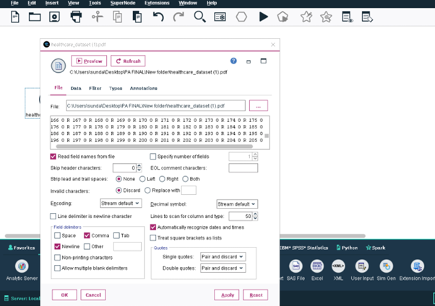
4.3 Adding the Data Audit Node
- I dragged the Var. File node and loaded the Healthcare CSV dataset.
- From the Output palette, I dragged the Data Audit node onto the stream.
- I connected the Var. File → Data Audit.
4.4 Running the Data Audit
- I right-clicked the Data Audit node.
- Selected Run to generate the data quality report.
Observing Variable Summaries
The Data Audit node automatically produced a summary for all fields, including:
- Measurement level
- Minimum, maximum
- Mean and standard deviation (for numeric fields)
- Missing value count
- Outlier detection
- Distribution plots

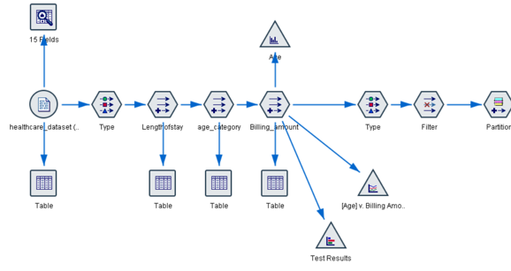

Step: Identifying Major Data Quality Issues
From the Data Audit output, I identified the following issues:
- Missing Values in
  - Blood Type
  - Insurance Provider
  - Medical Condition
- Outliers in
  - Billing Amount
  - Age
- Inconsistent Values
  - Some Admission Type or Medication fields had uncommon categories.

4.5 Extracting Descriptive Statistics
Based on the Data Audit table:
- Age
  - Minimum =
  - Maximum =
  - Mean =
  - Std dev =
- Billing Amount
  - Minimum =
  - Maximum =
  - Mean =
- LengthOfStay (after derivation)
  - Minimum =
  - Maximum =
  - Average =

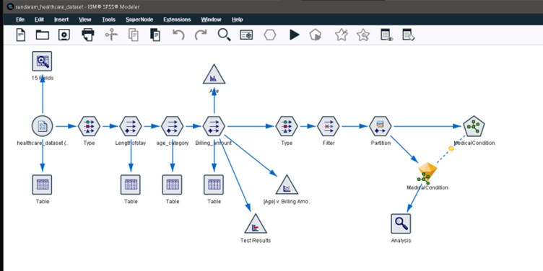

5. Conclusion And Summary

The Data Audit performed on the healthcare dataset using IBM SPSS Modeler provided valuable insights into the overall structure and quality of the data. The audit results showed that several variables contained missing values, particularly in Blood Type, Insurance Provider, and Medical Condition. Numerical fields such as Age and Billing Amount displayed noticeable outliers, indicating the need for further cleaning or transformation. Some categorical fields also contained inconsistent or uncommon entries.
Overall, the analysis highlighted important data quality issues that must be addressed before applying any predictive or statistical modeling. The Data Audit helped identify areas requiring imputation, standardization, and correction, ensuring that the dataset becomes reliable, accurate, and ready for further analysis in future stages.

